**PORTFOLIO**

**COMPUTER SCIENCE AND ENGINEERING**

Submitted by:

Name: Sarthak Pattewar

Registration number: 12406757

Roll No.: RK24CTB63

Section: K24CT

**Submitted to : Dr. Joshva Raj G**



**LOVELY PROFESSIONAL UNIVERSITY**

**DECLARATION**

I, Sarthak, a student of Bachelor of Technology under CSE discipline at Lovely Professional University, Punjab, hereby declare that all the information furnished in this project report is based on my own work and is genuine

SARTHAK

Registrartion Number: 12406767

1.FIGMA

Profile:

Figma internal profile with project

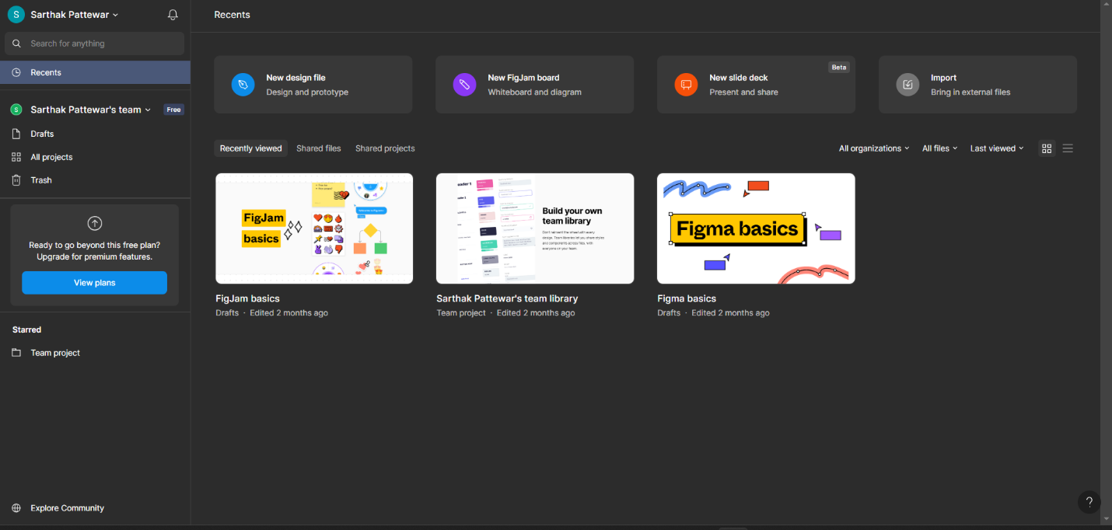

2.QUORA

PROFILE AND ACCOMPLISHMENT:

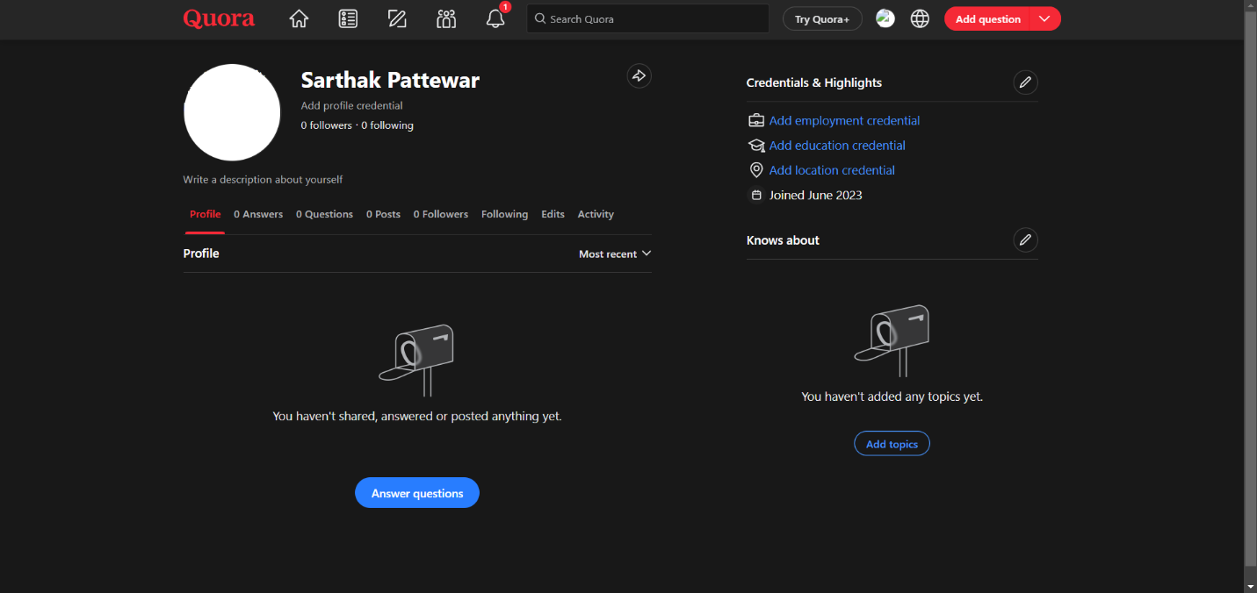

3.STACKOVERFLOW

PROFILE:

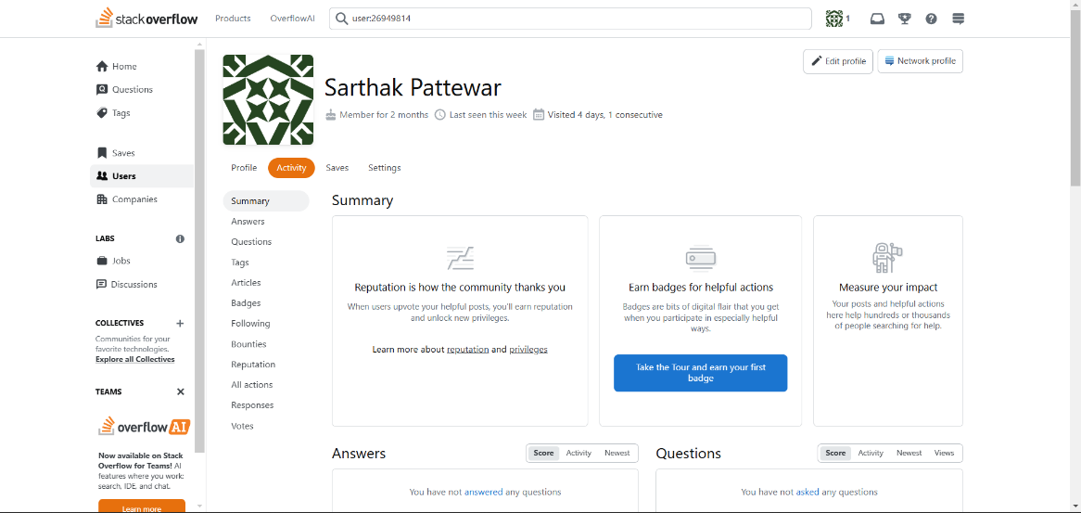

**4.HACKER RANK**

**Profile:** 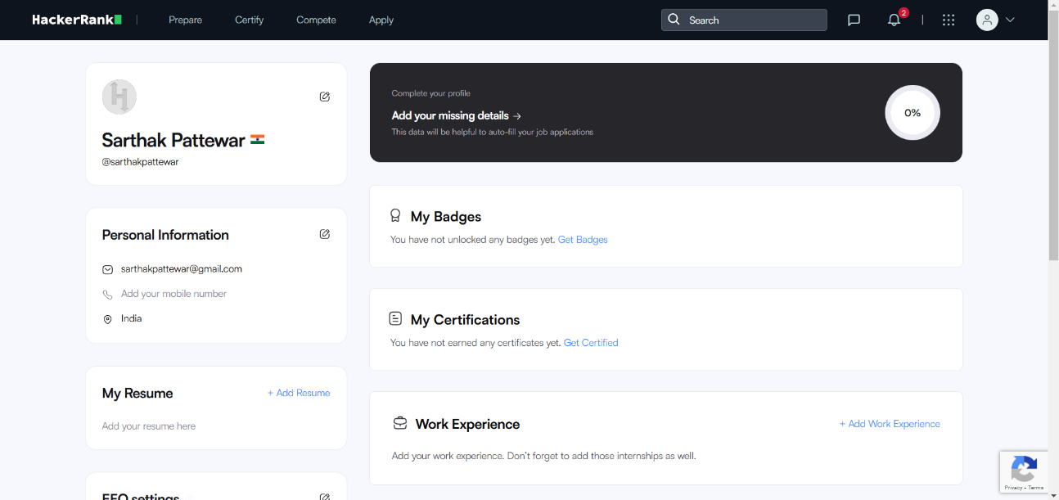

**5.HACKER EARTH**

**Profile:**

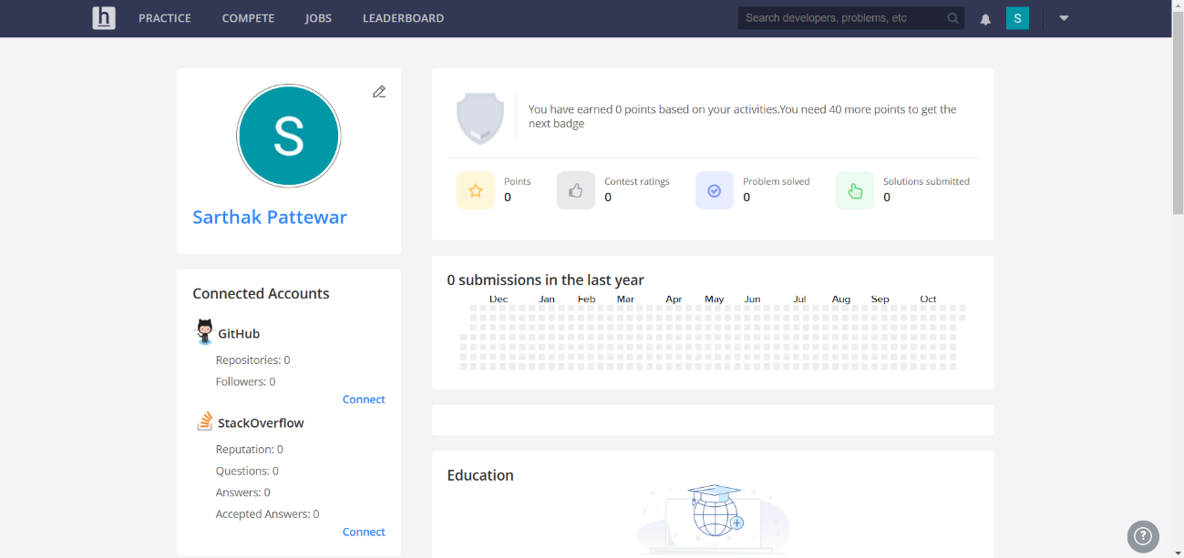

**6.GEEKS FOR GEEKS**

**Profile:**

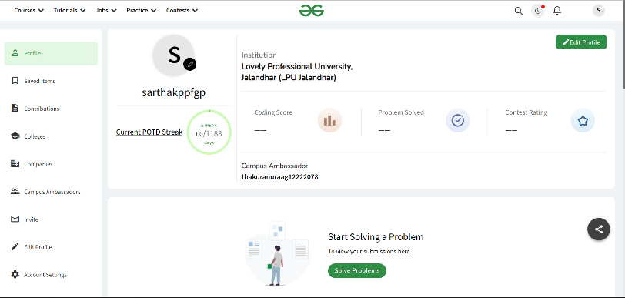

**8. GITHUB**

**Profile:**

